**SMTP Setup for Mail using ASP / PHP**

1. Install SMTP onto the server.
2. From IIS Manager right click SMTP Virtual Server and choose Properties from the drop down menu.
3. From the properties choose the Access Tab and click the Relay Button.

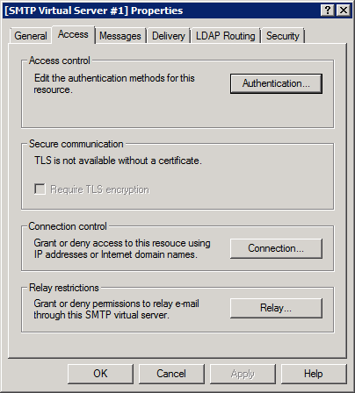

1. From the Relay Restrictions dialog check “Only the list below” and add 127.0.0.1 and the IP of the machine. Then click OK.

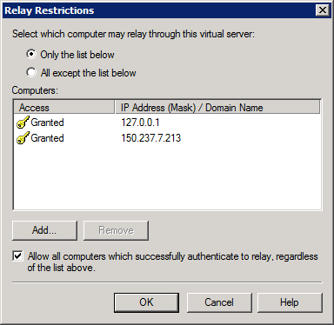

1. From the properties choose the Delivery Tab and click Advanced at the bottom of the screen.

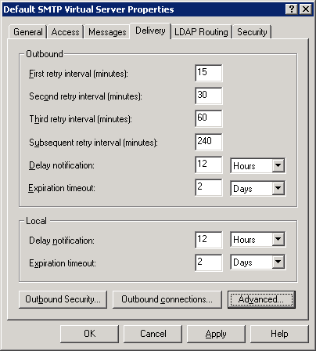

1. Finally add to the Smart host option mservers.hull.ac.uk.

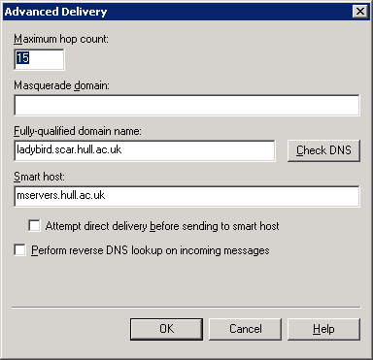

1. Click the OK button exit out of the Properties windows.

Notes:

1. The server IP address must be registered with hull to allow mservers.hull.ac.uk to accept connections from this server.
2. The Antivirus software must allow port 25 connections.
3. The PHP.ini file needs setting with a sendmail_from address.